“Texas Run to the Wall”
30th Anniversary!
Memorial Event & Celebration Run!
*** Save the Date - November 10th, 2018 ***

Meet Up at Ranger Stadium for Run Registration and Police Escorted
Ride to Fair Park, Texas Vietnam War Memorial - Parry Ave, Dallas, TX 75226
Then Go Across the Street -Party with the Vets As We Celebrate Our Freedom!
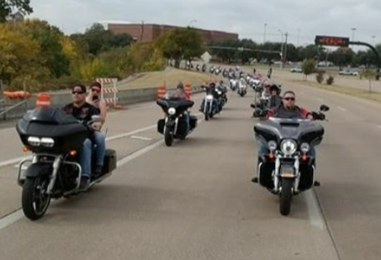 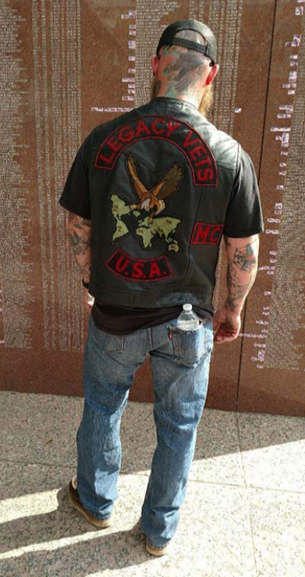
Everyone Welcome! Make this 30th the Biggest Memorial
Bike Run Ever! In Honor of ALL VETERANS!
After Party - Food - Band and More
Organized by the Viet Nam Vets / Legacy Vets Motorcycle Club
*** Onsite Registrations Starts at 9AM, Bikes Leave for Memorial about 12 Noon ***
*** Memorial Event Starts at about 1PM ***
Get the Latest Info On www.TXWall.com
Points of Contact: Link: 817-681-9943, Rat Pack: 623-760-6617 & Herf: 714-458-9498

