30th AND 31st Anniversaries!!!
“Texas Run to the Wall”
Vietnam War Memorial Event & Celebration!
** November 9th, 2019 **
30TH ANNIVERSARY FOR THE VIETNAM WAR MEMORIAL WALL
31ST ANNIVERSARY FOR THIS RIDE TO THE WALL EVENT!

… Ride Schedule…
1. Morning Meet Up at Ranger Stadium for Run Registration
2. Ride to Fair Park, Texas Vietnam War Memorial - Parry Ave, Dallas, TX 75226
3. Then Go Across the Street & Party with the Vets as We Celebrate Our Freedom!

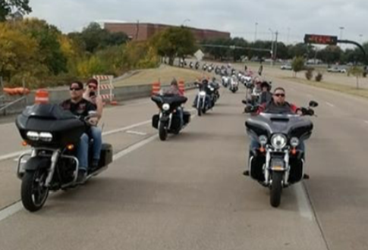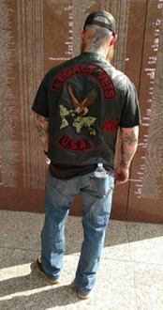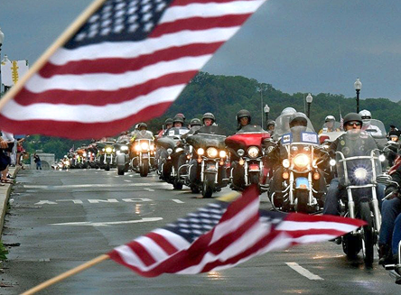

Everyone Welcome! Make this 30th & 31st the Biggest Memorial
Bike Run Ever! In Honor of ALL VETERANS!
150 Bikes Road to the Texas Vietnam Memorial Site Last Year. Ride with Us This Year!
After Party - Food - Band and More - Registration on Saturday (Day of the Event): Single $20 – Couple $25
Departure Time, SAVE with Online Registration , AND Other Info. on www.TXWall.com
Event Organized by the Viet Nam Vets / Legacy Vets Motorcycle Club
Points of Contacts: Link: 817-681-9943, Rat Pack: 623-760-6617 & Gunz: 214-250-0222

