“Texas Run to the Wall”
Vietnam War Memorial Event & Celebration!
32nd Anniversary of Honoring All Who Served
** November 7th, 2020 **
--
… Ride Schedule…
- Registration starts at 9 AM in the Arlington Ball Park Parking Lot “F”.
- Leave for Texas Vietnam Memorial at 12:00 Noon
- Arrive at Texas Vietnam War Memorial at 12:30 PM, Parry Ave, Dallas, TX 75226
- Memorial Event will begin at 1:00 PM.

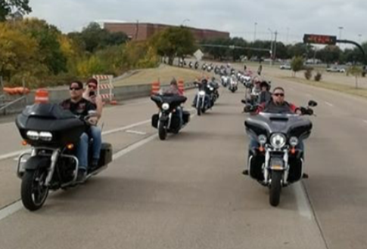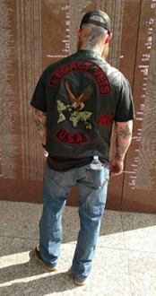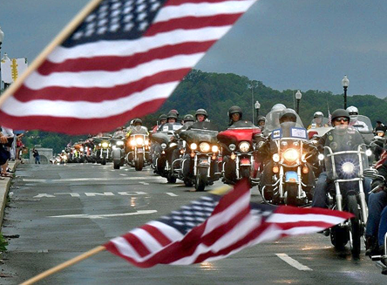

This Event Is in Honor of ALL VETERANS!
Large Pack of Bikes rode to the Texas Vietnam Memorial Site Last Year. Ride with Us This Year!
After Party - Food - Band and More - Registration on Saturday (Day of the Event): Single $20 – Couple $25
SAVE Time & Money with Online Early Registration
Go To www.TXWall.com
Event Organized by the Viet Nam Vets Legacy Vets Motorcycle Club
Points of Contacts: Link: 817-681-9943, Rat Pack: 623-760-6617 & Gunz: 214-250-0222

